Voting System
This application will be used for corporate voting. In real life, there might be lots of business logics, features of such kind of applications, but we keep it very simple to judge your skill and learning by this lab test. You will only implement the features and logics mentioned here and are NOT allowed to change these or to implement new logics.

Everything of this voting system has been described below and it is assumed that you will understand everything going through each story. So, read the entire specification carefully and if needed, ask invigilators/examiners for more clarification. See the stories below:

- Candidate entry:
Using this story, user will enter name of candidates and their symbols for the election. Here, symbol name must be unique.

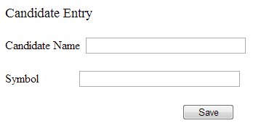

- No of winners entry:
User will enter number of winners for this election. A voter can’t cast votes more than ‘No of winners) (see story number: 3) and only this number of winners will be declared as winners (see story number: 4)

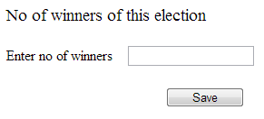

- Cast vote:
Voters (identified by email) will use this story for casting his/her votes for candidates. A voter can cast number of votes equals to or less than ‘no of winners’ (which has been entered by using story number: 2). Even if a voter can cast all of his/her votes for a single candidate if he/she wants.

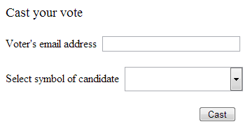

If this voter’s email doesn’t exist into the system, a message will be shown: “This voter doesn’t exist into the system.”

If a voter already casted all of his/her votes, a message will be shown: “This voter already casted all of his/her votes so his cann’t cast no more vote”

Note: You see that there’s no user interface for entering voter into the system. So, enter some voters (id and email is enough) into the system.

- View Result :
This is a report. Result of this election can be viewed using this story. Result will be displayed in ascending order of ‘No of votes’. This report must handle all the cases: win/loose/tie. Details explanation is given in next page. Following figure shows sample data.

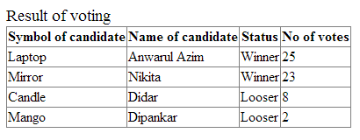

Details of View Result:
Suppose, ‘Number of winners’ of this election is three (which is actually configured by user using story number: 3). Now see the following cases:
Case 1:
Symbol of candidate | Name of candidate | Status | No of votes
Laptop | Anwarul Azim | Winner | 20
Mirror | Nikita | Winner | 12
Candle | Didar | Winner | 11
Mango | Dipankar | Looser | 3
Case 2:
Symbol of candidate | Name of candidate | Status | No of votes
Laptop | Anwarul Azim | Winner | 20
Mirror | Nikita | Winner | 20
Candle | Didar | Winner | 20
Mango | Dipankar | Looser | 19
Case 3:
Symbol of candidate | Name of candidate | Status | No of votes
Laptop | Anwarul Azim | Winner | 20
Mirror | Nikita | Winner | 20
Candle | Didar | Looser | 15
Mango | Dipankar | Looser | 15
Case 4:
Symbol of candidate | Name of candidate | Status | No of votes
Laptop | Anwarul Azim | Tie | 20
Mirror | Nikita | Tie | 20
Candle | Didar | Tie | 20
Mango | Dipankar | Tie | 20
Case 5:
Symbol of candidate | Name of candidate | Status | No of votes
Laptop | Anwarul Azim | Winner | 20
Mirror | Nikita | Looser | 15
Candle | Didar | Looser | 15
Mango | Dipankar | Looser | 15

